
Kolbe Catholic College

YEAR 12 CHEMISTRY EXAMINATION

SEMESTER ONE 2002

STUDENT NAME: __________________________________________

TIME ALLOWED FOR THIS PAPER

Reading time before commencing work: Ten minutes
Working time for paper: Three hours

MATERIAL REQUIRED/RECOMMENDED FOR THIS PAPER

TO BE PROVIDED BY THE SUPERVISOR

This Question/Answer Booklet
Separate Multiple Choice Answer Sheet
Chemistry Data Sheet (inside front cover of this Question/Answer Booklet)

TO BE PROVIDED BY THE CANDIDATE

Standard Items: Pens, pencils, eraser or correction fluid, ruler

Special Items: A 2B, B or HB pencil for the separate Multiple Choice Answer Sheet and calculators satisfying the conditions set by the Curriculum Council.

IMPORTANT NOTE TO CANDIDATES

No other items may be taken into the examination room.

It is your responsibility to ensure that you do not have any unauthorised notes or other items of a non-personal nature in the examination room. If you have any unauthorised material with you, hand it to the supervisor BEFORE reading any further.

STRUCTURE OF THE PAPER
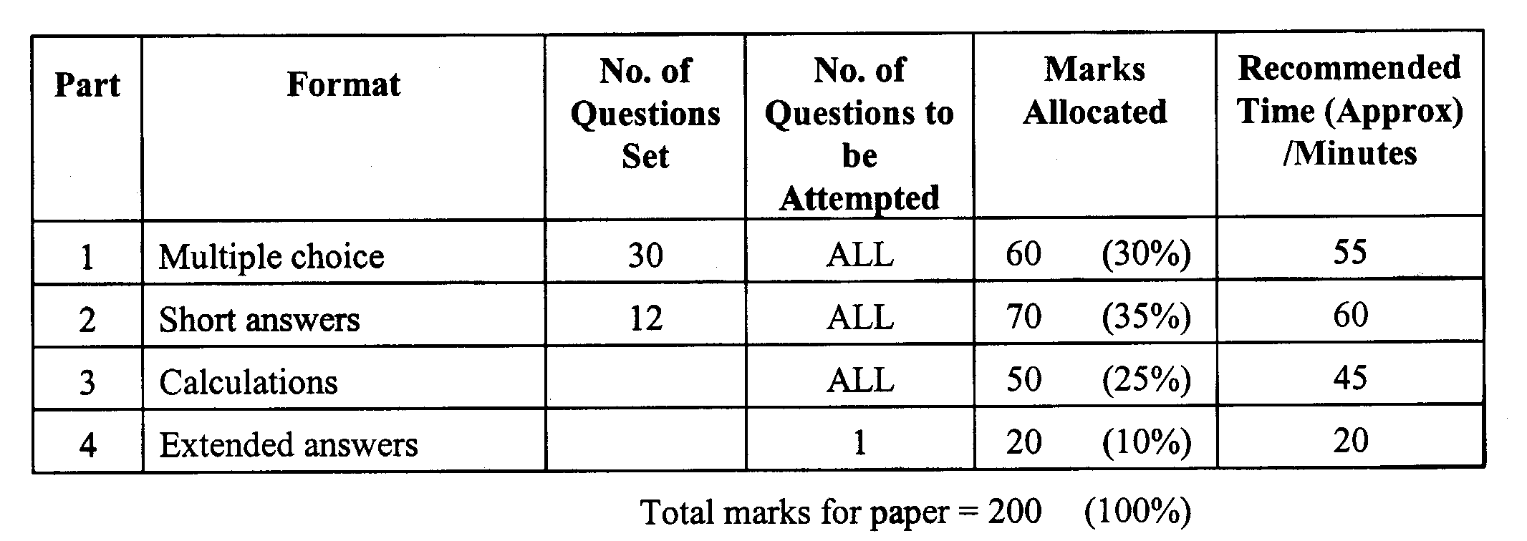
6
2

INSTRUCTIONS TO CANDIDATES

Reading Time: The examiners recommend that candidates spend the reading time mainly reading the Instructions to Candidates and Parts 2, 3 and 4.

Part 1: Multiple Choice

Answer ALL questions, using a 2B, B or HB pencil, on the separate Multiple Choice Answer Sheet. Do NOT use a ball point or ink pen.

If you consider that two or more of the alternative responses are correct, choose the one you think is best. If you think you know an answer, mark it even if you are not certain you are correct. Marks will not be deducted for incorrect answers.

FEEL FREE TO WRITE OR DO WORKING ON THE QUESTION PAPER; many students who score high marks in the Multiple Choice Section do this.

Parts 2, 3 and 4

Use a ball point or ink pen. Do not answer in pencil. Write your answers in this Question/Answer Booklet.

At the end of the examination, check that your Name has been placed in the spaces provided on the front cover of this Question/Answer Booklet and on your separate Multiple Choice Answer Sheet.

Questions containing specific instructions to show working should be answered with a complete logical, clear sequence of reasoning showing how the final answer was arrived at; correct answers which do not show working will not be awarded full marks.

CHEMICAL EQUATIONS

For full marks, chemical equations should refer only to those species consumed in the reaction and the new species produced. These species may be ions [for example Ag⁺(aq)], molecules [for example NH₃(g), NH₃(aq), CH₃COOH (l), CH₃COOH (aq)] or solids [for example BaSO₄(s), Cu(s), Na₂CO₃(s)].

PART 1 (60 marks = 30% of paper)

Answer ALL questions in Part 1 on the Separate Multiple Choice Answer Sheet provided, use a 2B, B or HB pencil. Each question in this part is worth 2 marks.
_____________________________________________________________________

1. Calculate the mass of solute dissolved in 250 mL of 0.2 mol L⁻¹ sodium hydroxide solution.

a) 0.1 g b) 0.2g
c) 2.0 g d) 8.0g

2. 100 mL of 2.00 mol L⁻¹ sodium hydroxide is mixed with 50.0 mL of 2.50 mol L⁻¹ sodium hydroxide, then 50.0 mL of distilled water is added to the solution.
What is the concentration of the final sodium hydroxide solution produced?

a) 1.62 mol L⁻¹ b) 2.17 mol L⁻¹
c) 2.25 mol L⁻¹ d) 2.40 mol L⁻¹

3. Calculate the concentration of chloride ions in 20 mL of a 0.5 mol L⁻¹ solution of aluminium chloride.

a) 0.5 mol L⁻¹ b) 1.0 mol L⁻¹
c) 1.5 mol L⁻¹ d) 2.0 mol L⁻¹

4. Consider the following two solutions:

Solution 1 consists of 1 mol L⁻¹ iron (III) sulfate and Solution 2 consists of 1 mol L⁻¹ sodium sulfate.

Which of the following statements is TRUE?

a) The [SO₄²⁻] in Solution 1 is 1.5 times the [SO₄²⁻] in Solution 2.
b) The [Na⁺] is Solution 2 is equal to the [Fe³⁺] in Solution 1.
c) The [Na⁺] in Solution 2 is half the [SO₄²⁻] in Solution 1.
d) The [Fe³⁺] in Solution 1 is equal to the [SO₄²⁻] in Solution 2.

5. Identify which ONE of the following pairs of solutions would produce a precipitate when mixed together.

a) Fe(NO₃)₃ and K₃PO₄.
b) NH₄NO₃ and Na₂CO_{3.}
c) Ca(NO₃)₂ and NaCl.
d) MgCl₂ and NaBr.

6. What colour is Fe(OH)₂?

a) Green.
b) Brown.
c) White.
d) Yellow.
7. Which one of the equations below is NOT balanced?

a) 2KClO₃ 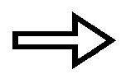 2KCl + 2O₂
b) Fe₂O₃(s) + 3CO(g) 2Fe(l) + 3CO₂(g)
c) Zn(s) + 2HCl(aq) ZnCl₂(aq) + H₂(g)
d) 2HgO 2Hg + O₂

The next two questions refer to the equation below which shows the decomposition of zinc carbonate upon heating.
_{heat}
ZnCO₃(s) ZnO(s) + CO₂(g)

8. If 2.5 g of zinc carbonate is heated, what mass of zinc oxide would be produced?

a) 0.02 g b) 0.8 g
c) 1.6 g d) 3.2 g

9. If the carbon dioxide produced in the above reaction was collected and conditions set to STP, what volume would the carbon dioxide gas occupy?

a) 88.0 mL b) 100.0 mL
c) 22.4 mL d) 448 mL

10. The equation for the reaction between hydrochloric acid and sodium thiosulfate can be represented as :

S₂O₃²⁻(aq) + 2H⁺(aq) H₂O(l) + SO₂(g) + S(s)

Which one of the following would NOT increase the rate of this reaction?

a) Increasing the temperature of the reacting solutions.
b) Increasing the concentration of sodium thiosulfate.
c) Increasing the concentration of the hydrochloric acid used.
d) Increasing the air pressure around the reaction vessel.

11. The equilibrium expression, k, for the reaction:

N₂O₄(g) 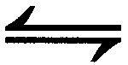 2NO₂(g), would be

a) k = [N₂O₄]
2[NO₂]
b) k = 2[NO₂]
[N₂O₄]
c) k = [N₂O₄]
[NO₂]²
d) k = [NO₂]²
[N₂O₄]

12. What would happen to the value of k in the reaction described in question 11, if the pressure of the N₂O₄ is doubled?

a) k would not be affected.
b) k would be halved.
c) k would be doubled.
d) k would increase by a factor of 4.

13. Which of the following is used as a primary standard in acid-base titrations?

a) Hydrochloric acid.
b) Sodium carbonate.
c) Sodium hydroxide.
d) Sulfuric acid.

14. Which one of the following acids is diprotic?

a) Nitric acid.
b) Phosphoric acid.
c) Ethanoic acid.
d) Sulfuric acid.

15. If a solution has a pH of 10, then the hydroxide ion concentration of the solution is

a) 10 mol L⁻¹
b) 0.1 mol L⁻¹
c) 0.04 mol L⁻¹
d) 0.0001 mol L⁻¹

16. In volumetric analysis work, the following items of glassware are used:

I. Pipette
II. Volumetric flask
III. Conical flask
IV. Burette

Which of these items must be rinsed with a sample of the solution they will contain prior to them being filled with this solution for a titration?

a) All of them
b) I and IV.
c) I, II and IV.
d) III only.

17. The diagram below shows the level of hydrochloric acid in the burette immediately before and after a titration.

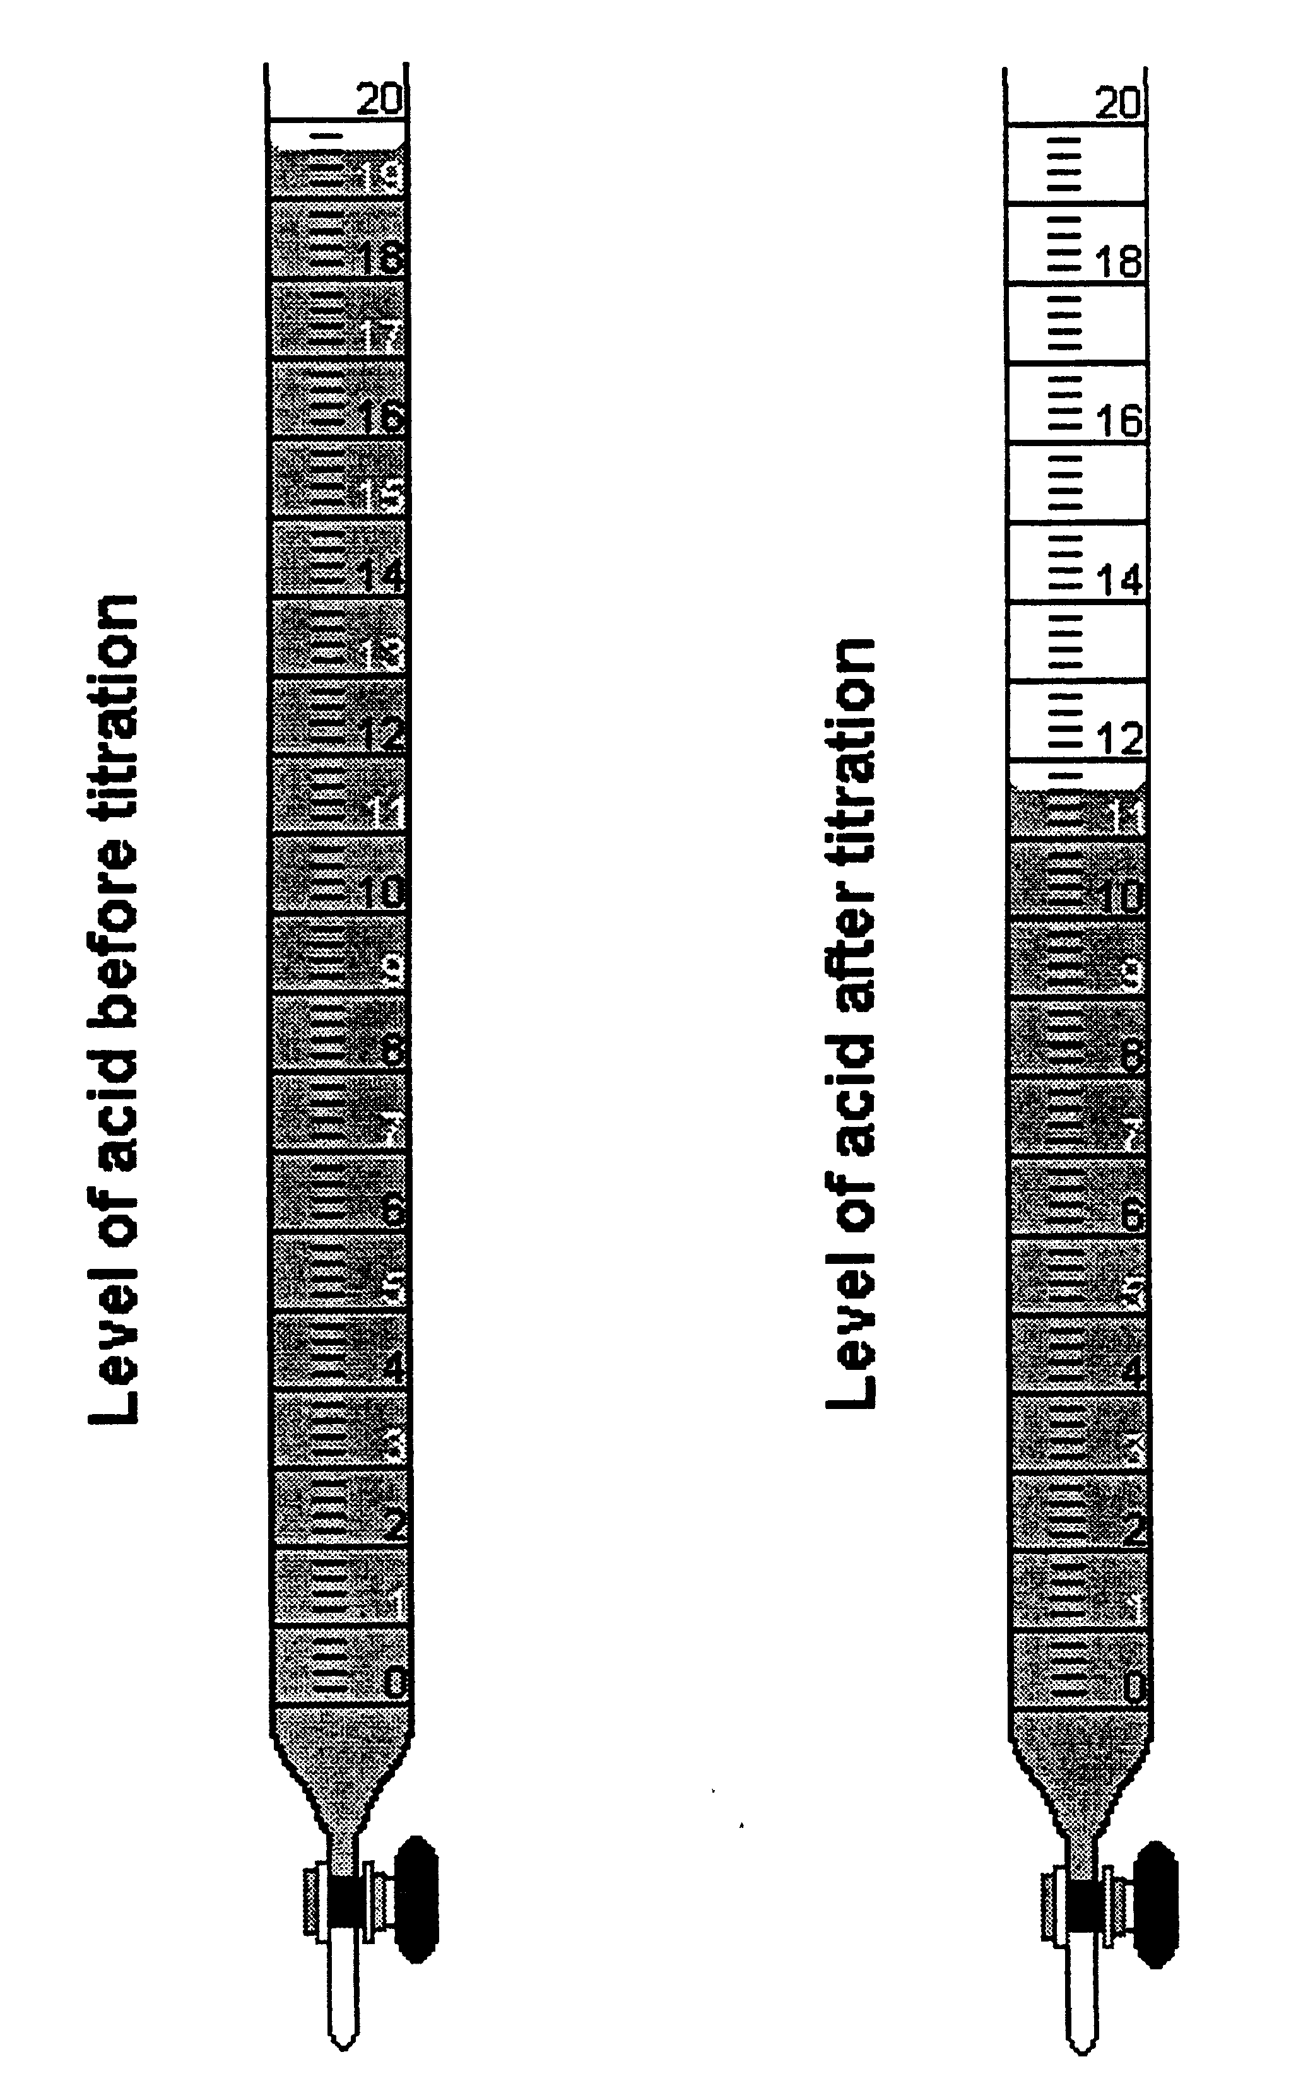

What volume of acid has been used in this titration?

a) 7.0 mL
b) 8.0 mL
c) 8.2 mL
d) 11.6 mL

18. What instrument should be used to accurately measure and deliver exactly 20 mL of the primary standard?

a) A graduated cylinder.
b) An eyedropper.
c) A burette.
d) A pipette.

19. Which one of the following is a reason why potassium permanganate is unsuitable as a primary standard?

a) The exact molecular formula is unknown.
b) Potassium permanganate is an oxidising agent.
c) Solutions of potassium permanganate are unstable and decompose when exposed to light.
d) Its molar mass is too high.

20. Study the following equation for the reaction between concentrated nitric acid and copper metal and then answer the question below.

Cu(s) + 4H⁺(aq) + 2NO₃⁻(aq) Cu²⁺(aq) + 2H₂O(l) + 2NO₂(g)

The reducing agent is

a) copper metal.
b) nitric acid.
c) hydrogen ions.
d) nitrogen doxide.

21. Which one of the following is a strong oxidising agent, used both as a bleaching agent and in the purification of water?

a) Hydrogen peroxide, H₂O₂.
b) Hypochlorite ion, OCl⁻.
c) Hydrogen chloride, HCl.
d) Sulfuric acid, H₂SO₄.

22. What would you expect to observe when chlorine is added to a solution of sodium bromide.

a) The solution would turn red.
b) A purple precipitate would be formed.
c) There would be no reaction.
d) The solution would become green.

23. What is the oxidation number of manganese in the permanganate ion, MnO₄⁻?

a) –1 b) +7
c) -7 d) +8

24. Oxidation occurs when

a) a substance donates hydrogen ions.
b) a substance becomes negatively charged.
c) a substance gives up electrons.
d) a substance gains electrons.

25. Which of the following oxides is acidic?

a) Na₂O
b) MgO
c) Al₂O₃
d) SO₂

The next two questions refer to the information below.

In the extraction of iron in the blast furnace, a mixture of iron ore, coke (form of carbon) and limestone is used.
The overall reaction is:
Fe₂O₃(s) + 3CO(g) 2Fe(s) + 3CO₂(g)

26. What is the function of the limestone in the extraction process?

a) It acts as a catalyst in the reaction.
b) Its decomposition at high temperatures provides the calcium oxide and carbon dioxide needed for the extraction process.
c) It forms a layer of slag over the iron to prevent its oxidation.
d) It acts as an insulator of heat.

27. With reference to the above equation, which of the following statements is true?

a) The carbon monoxide acts as a reducing agent.
b) The iron (II) oxide is oxidised in the reaction.
c) The oxidation state of the iron has changed from +2 to 0.
d) The carbon monoxide is reduced in the reaction.

Questions 28 and 29 refer to the information below.

The reaction for the extraction of gold by the ’MacArthur and Forrest ‘ gold cyanide process is:

4Au(s) + 8CN⁻(aq) + 2H₂O(l) + O₂(g) 4[Au(CN)₂]⁻(aq) + 4OH⁻(aq)

28. Which one of the following statements is false?

a) The cyanide ion is used to assist the oxidation of gold.
b) The oxidation state of the gold changes from 0 to +1.
c) Cyanide ions are reduced.
d) The oxygen acts as the oxidising agent in the reaction.

29. To recover the gold from the auro-cyanide ion produced in the above reaction, it is reduced by a displacement reaction with

a) iron.
b) zinc.
c) calcium oxide.
d) magnesium.

30. The ion formed when excess ammonia solution is added to a solution containing copper (II) ions is

a) [Cu(NH₃)₄]²⁺
b) [Cu(NH₃)₆]⁺
c) [Cu₂(NH₃)₄]²⁺
d) [Cu(NH₃)₂]²⁺

END OF PART 1

PART 2 (70 marks = 35% of paper)

Answer ALL questions in Part 2 in the spaces provided below.
_____________________________________________________________________

Question 1

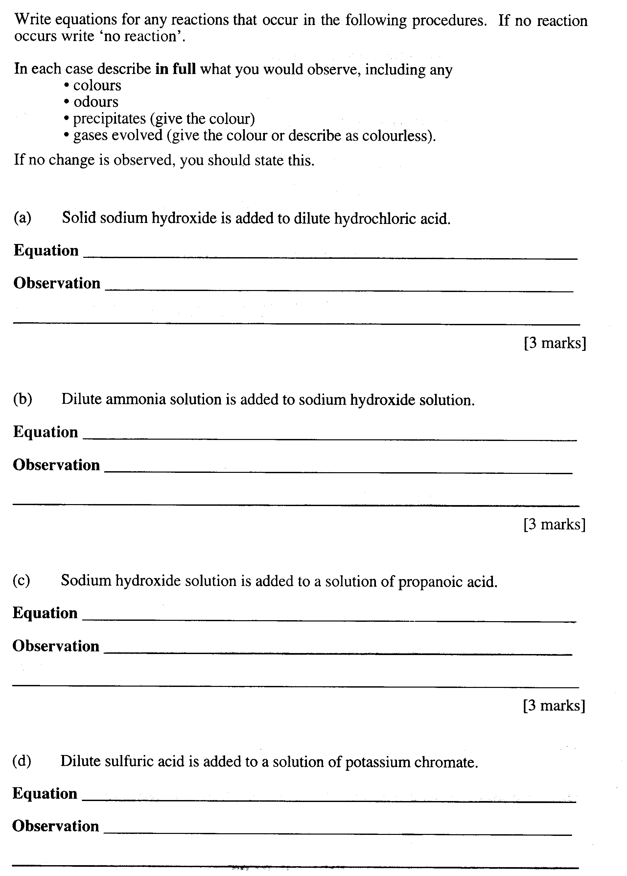
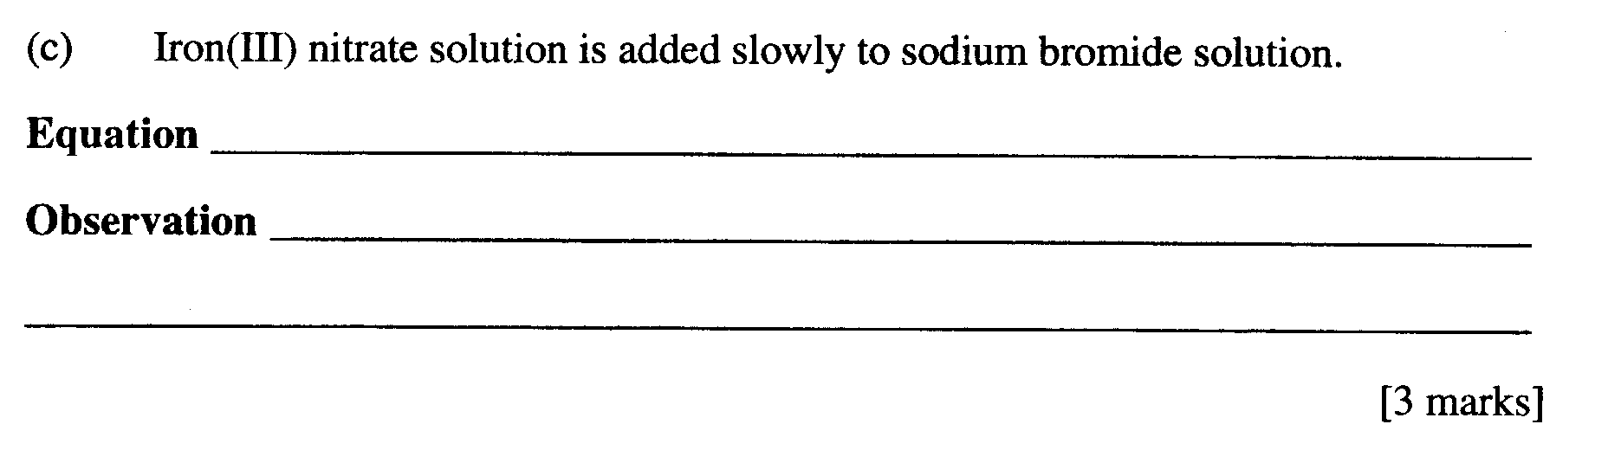

[3 marks]

Question 2

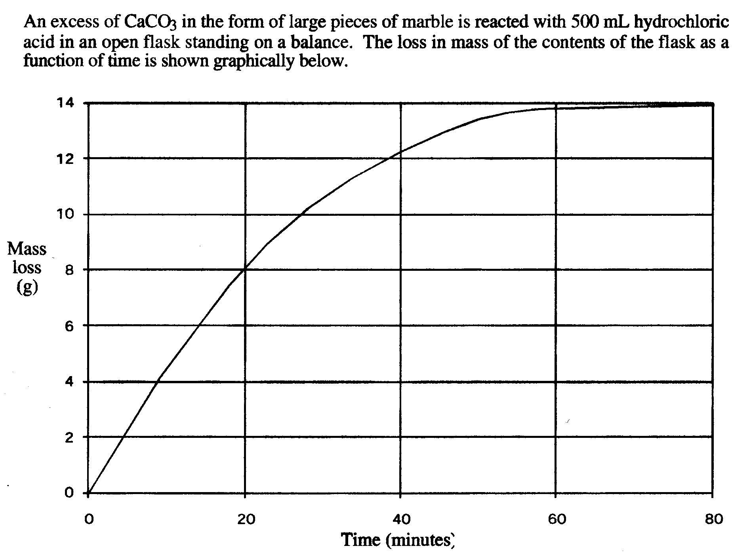
(a)

[2 marks]

_____________________________________________________________________

_____________________________________________________________________

_____________________________________________________________________

_____________________________________________________________________
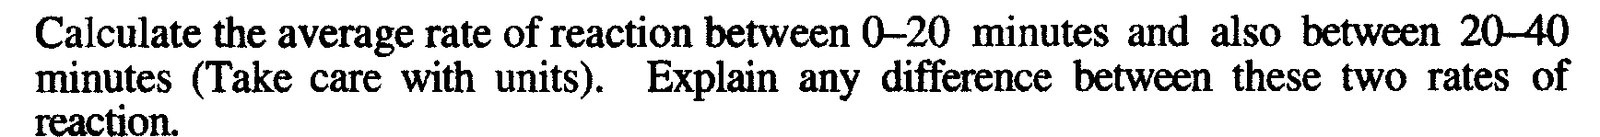
(b)

[2 marks]

_____________________________________________________________________

_____________________________________________________________________

_____________________________________________________________________

_____________________________________________________________________

_____________________________________________________________________

(c)

[1 mark]

_____________________________________________________________________

_____________________________________________________________________

_____________________________________________________________________

_____________________________________________________________________
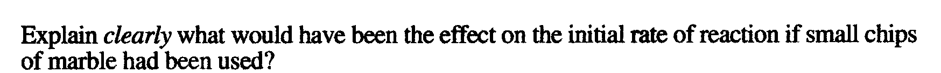
(d)

[1 mark]

_____________________________________________________________________

_____________________________________________________________________

_____________________________________________________________________

Question 3

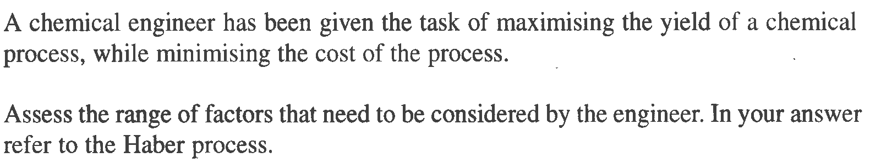
[5 marks]

_____________________________________________________________________

_____________________________________________________________________

_____________________________________________________________________

_____________________________________________________________________

_____________________________________________________________________

_____________________________________________________________________

_____________________________________________________________________

_____________________________________________________________________

_____________________________________________________________________

_____________________________________________________________________

Question 4

Identify by name or formula an example of each of the following

Description | Name or Formula
A positively charged complex ion
A halogen which is liquid at room temperature and pressure

A salt that dissolves in water to give an acidic solution

A weak acid other than acetic acid

A substance that can be used as a primary standard for redox titrations

A diprotic acid

A secondary standard used in many acid-base titrations

[7 marks]

Question 5

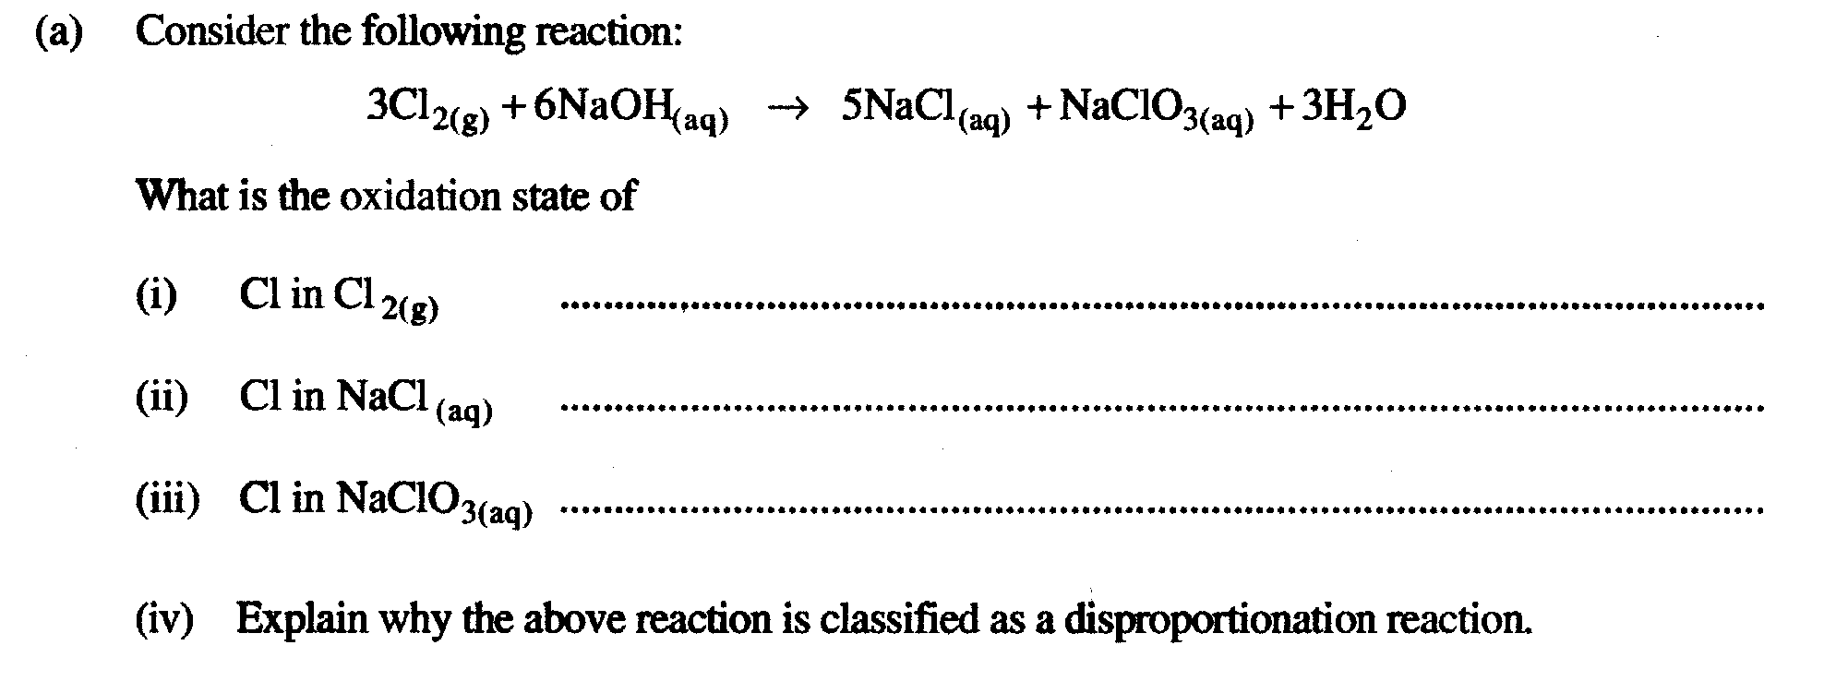
[4 marks]

____________________________________________________________

____________________________________________________________

____________________________________________________________

____________________________________________________________

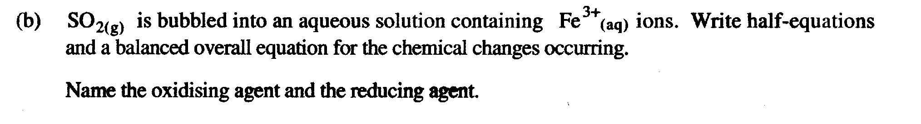
[4 marks]

_______________________________________________________________

_______________________________________________________________

_______________________________________________________________

_______________________________________________________________

_______________________________________________________________

_______________________________________________________________

Question 6

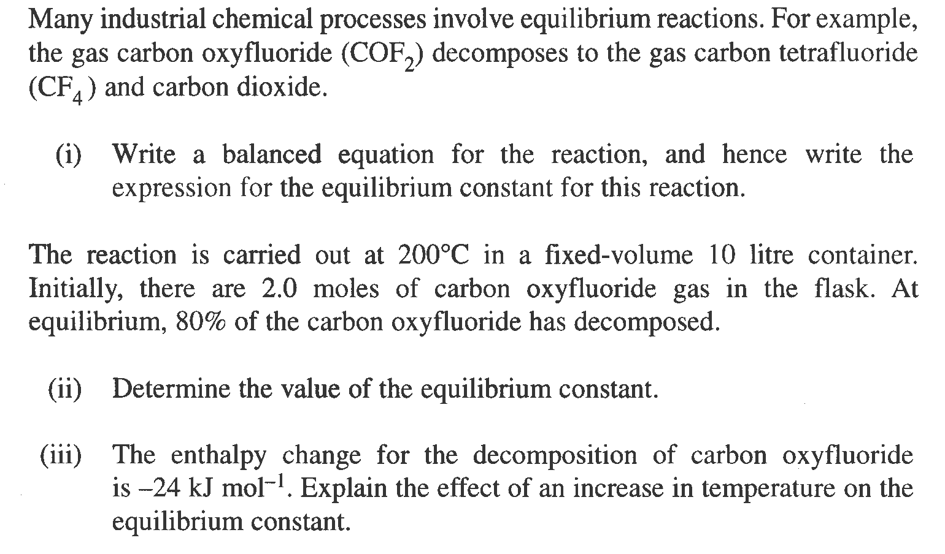
[2 marks]

_____________________________________________________________________

_____________________________________________________________________

_____________________________________________________________________

_____________________________________________________________________

[3 marks]

_____________________________________________________________________

_____________________________________________________________________

_____________________________________________________________________

_____________________________________________________________________

_____________________________________________________________________

_____________________________________________________________________

_____________________________________________________________________

[1 mark ]
_____________________________________________________________________

_____________________________________________________________________

_____________________________________________________________________

_____________________________________________________________________

_____________________________________________________________________

_____________________________________________________________________

_____________________________________________________________________

Question 7

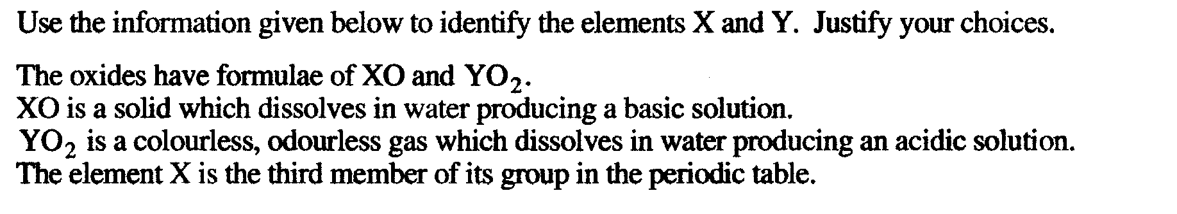
[3 marks]

_____________________________________________________________________

_____________________________________________________________________

_____________________________________________________________________

_____________________________________________________________________

_____________________________________________________________________

_____________________________________________________________________

_____________________________________________________________________

_____________________________________________________________________

Question 8

Consider the equilibrium reaction between hydrogen chloride gas and oxygen gas using a suitable catalyst:

4HCl(g) + O₂(g) 2H₂O(g) + 2Cl₂(g) ΔΗ = -280 kJ mol⁻¹

Complete the table below by:

- indicating the change in the amount of hydrogen chloride gas (write either “more”, “less” or “unchanged”) after each of the following changes to conditions at equilibrium have been made.

- giving also a brief reason for your choice based on accepted chemical principles.

Change imposed on the system | Effect on amount of HCl(g) present
1. The temperature of the  system is raised. | (a)………………………………………..………………….  (b) Reason…………………………………………………..  ………………………………………………………………  ………………………………………………………..……
2. The pressure of the  system is doubled by  halving the volume of the  reaction vessel. | (a)…………………………………………………………..  (b) Reason…………………………………..………………  ………………………………………………..….…………  ……………………………………………………..………
3. The surface area of the  catalyst is increased | (a)…………………………………………………….……..  (b) Reason………………………………………..…………  ………………………………………………………………  ………………………………………………………………

[9 marks]
Question 9

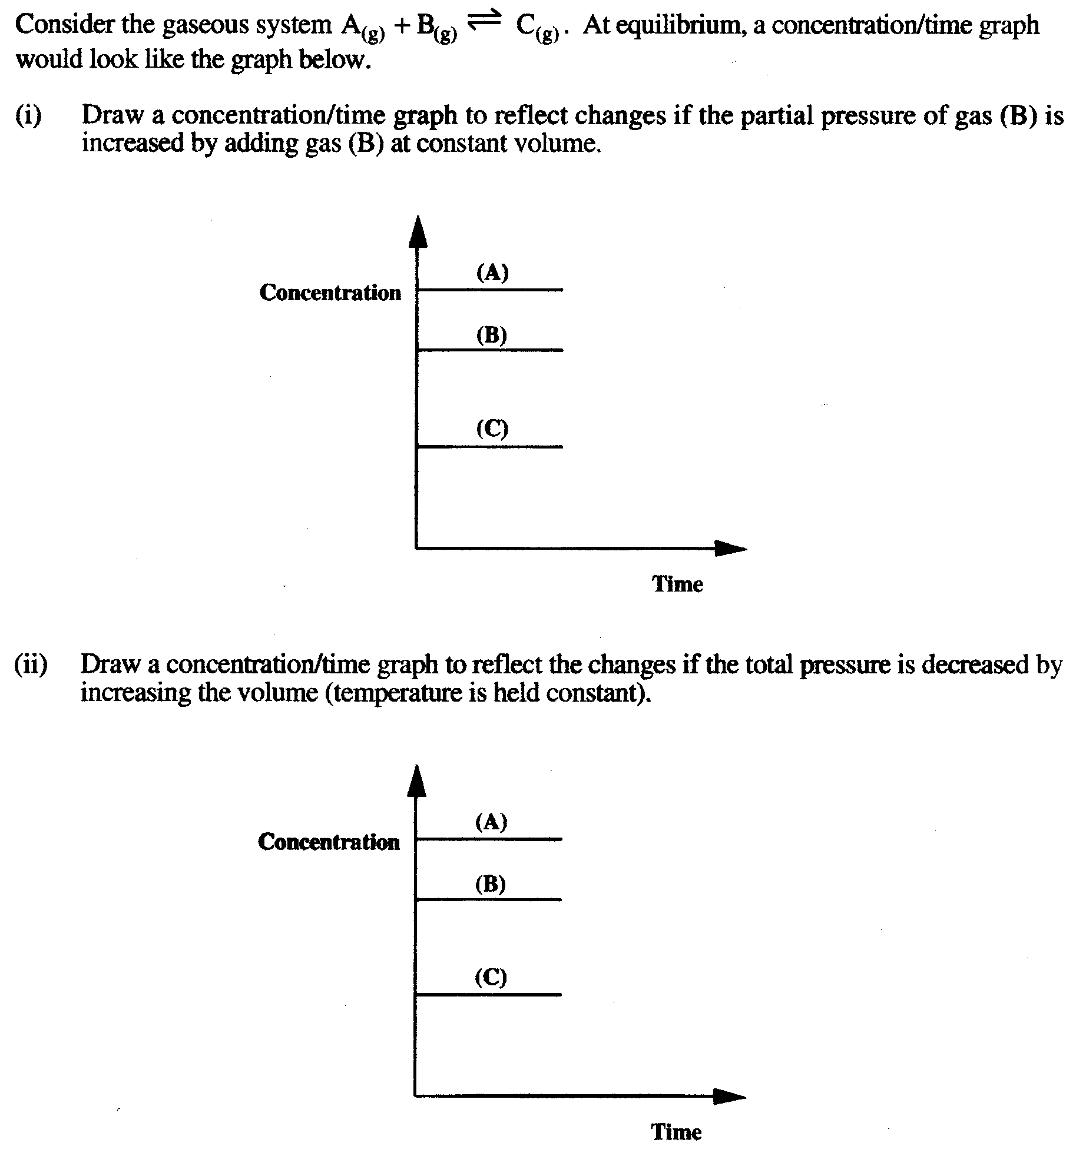
[3 marks]
[3 marks]
(a)
(b)

SEE NEXT PAGE

Question 10

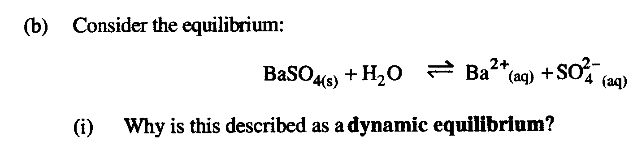

(a)
[2 marks]

_____________________________________________________________________

_____________________________________________________________________

_____________________________________________________________________

_____________________________________________________________________

_____________________________________________________________________

_____________________________________________________________________

_____________________________________________________________________

_____________________________________________________________________

(b)

[2 marks]

_____________________________________________________________________

_____________________________________________________________________

_____________________________________________________________________

_____________________________________________________________________

_____________________________________________________________________

_____________________________________________________________________

_____________________________________________________________________

_____________________________________________________________________

Question 11

What is the function of carbon in the CIP process?
[1 mark]

_____________________________________________________________________

_____________________________________________________________________

_____________________________________________________________________

Question 12

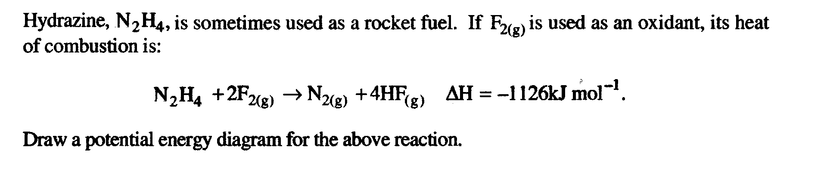
Show all information on the diagram.

[3 marks]

END OF PART 2

PART 3 (50 marks = 25% of paper)

Answer ALL questions in Part 3. The calculations are to be set out in detail in this Question/Answer Booklet. Marks will be allocated for correct equations and clear setting out, even if you cannot complete the problem. When questions are divided into sections, clearly distinguish each section using (a), (b), and so on. Express your final numerical answers to three (3) significant figures where appropriate, and provide units where applicable. Information which may be necessary for solving the problems is located on the separate Chemistry Data Sheet. Show clear reasoning: if you don’t, you will lose marks.
_____________________________________________________________________

Question 1

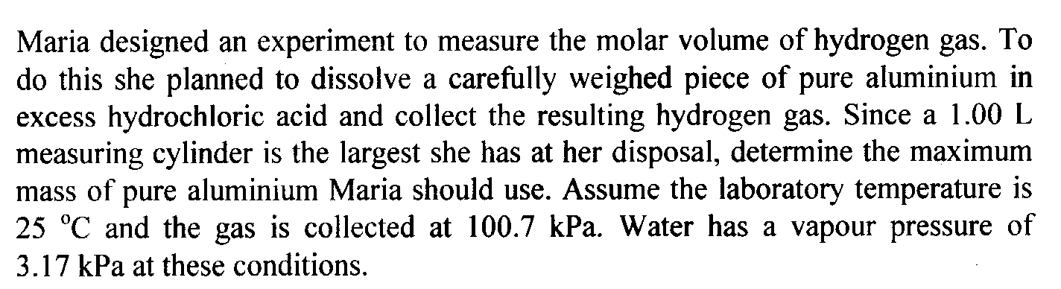

[6 marks]

_____________________________________________________________________

_____________________________________________________________________

_____________________________________________________________________

_____________________________________________________________________

_____________________________________________________________________

_____________________________________________________________________

_____________________________________________________________________

_____________________________________________________________________

_____________________________________________________________________

_____________________________________________________________________

_____________________________________________________________________

_____________________________________________________________________

_____________________________________________________________________

_____________________________________________________________________

_____________________________________________________________________

_____________________________________________________________________

_____________________________________________________________________

_____________________________________________________________________

_____________________________________________________________________

_____________________________________________________________________

_____________________________________________________________________

_____________________________________________________________________

_____________________________________________________________________

_____________________________________________________________________

_____________________________________________________________________

_____________________________________________________________________

_____________________________________________________________________

_____________________________________________________________________

_____________________________________________________________________

_____________________________________________________________________

_____________________________________________________________________

_____________________________________________________________________

_____________________________________________________________________

_____________________________________________________________________

_____________________________________________________________________

_____________________________________________________________________

_____________________________________________________________________

_____________________________________________________________________

_____________________________________________________________________

_____________________________________________________________________

_____________________________________________________________________

Question 2

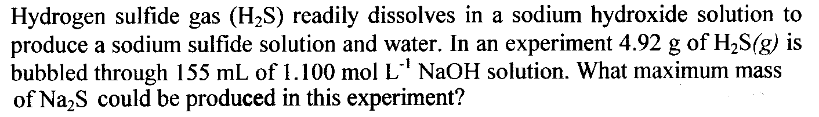
[8 marks]

_____________________________________________________________________

_____________________________________________________________________

_____________________________________________________________________

_____________________________________________________________________

_____________________________________________________________________

_____________________________________________________________________

_____________________________________________________________________

_____________________________________________________________________

_____________________________________________________________________

_____________________________________________________________________

_____________________________________________________________________

_____________________________________________________________________

_____________________________________________________________________

_____________________________________________________________________

_____________________________________________________________________

_____________________________________________________________________

_____________________________________________________________________

_____________________________________________________________________

_____________________________________________________________________

_____________________________________________________________________

_____________________________________________________________________

_____________________________________________________________________

_____________________________________________________________________

_____________________________________________________________________

_____________________________________________________________________

_____________________________________________________________________

_____________________________________________________________________

_____________________________________________________________________

_____________________________________________________________________

_____________________________________________________________________

_____________________________________________________________________

_____________________________________________________________________

_____________________________________________________________________

_____________________________________________________________________

_____________________________________________________________________

_____________________________________________________________________

_____________________________________________________________________

_____________________________________________________________________

_____________________________________________________________________

_____________________________________________________________________

_____________________________________________________________________

_____________________________________________________________________

_____________________________________________________________________

_____________________________________________________________________

_____________________________________________________________________

_____________________________________________________________________

_____________________________________________________________________

_____________________________________________________________________

Question 3

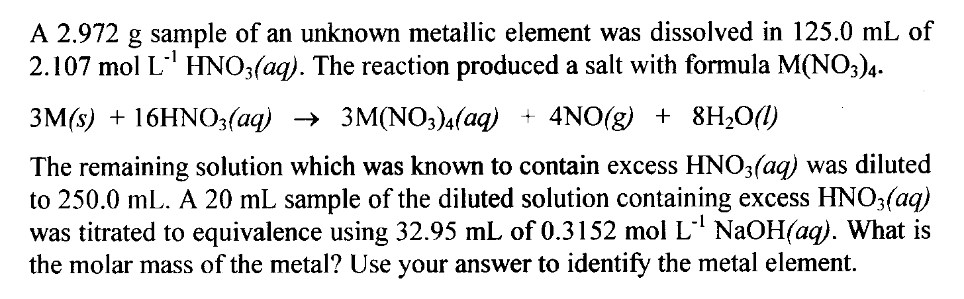
[9 marks]

_____________________________________________________________________

_____________________________________________________________________

_____________________________________________________________________

_____________________________________________________________________

_____________________________________________________________________

_____________________________________________________________________

_____________________________________________________________________

_____________________________________________________________________

_____________________________________________________________________

_____________________________________________________________________

_____________________________________________________________________

_____________________________________________________________________

_____________________________________________________________________

_____________________________________________________________________

_____________________________________________________________________

_____________________________________________________________________

_____________________________________________________________________

_____________________________________________________________________

_____________________________________________________________________

_____________________________________________________________________

_____________________________________________________________________

_____________________________________________________________________

_____________________________________________________________________

_____________________________________________________________________

_____________________________________________________________________

_____________________________________________________________________

_____________________________________________________________________

_____________________________________________________________________

_____________________________________________________________________

_____________________________________________________________________

_____________________________________________________________________

_____________________________________________________________________

_____________________________________________________________________

_____________________________________________________________________

_____________________________________________________________________

_____________________________________________________________________

_____________________________________________________________________

_____________________________________________________________________

_____________________________________________________________________

_____________________________________________________________________

_____________________________________________________________________

_____________________________________________________________________

_____________________________________________________________________

_____________________________________________________________________

_____________________________________________________________________

_____________________________________________________________________

_____________________________________________________________________

Question 4

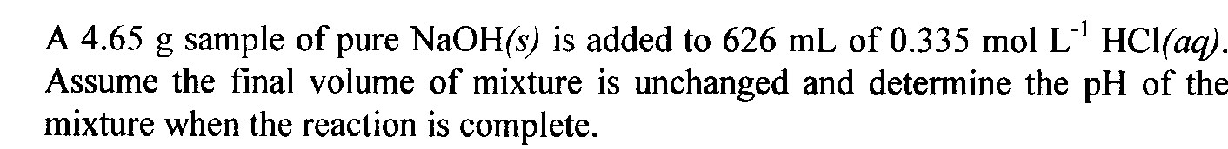
[8 marks]

_____________________________________________________________________

_____________________________________________________________________

_____________________________________________________________________

_____________________________________________________________________

_____________________________________________________________________

_____________________________________________________________________

_____________________________________________________________________

_____________________________________________________________________

_____________________________________________________________________

_____________________________________________________________________

_____________________________________________________________________

_____________________________________________________________________

_____________________________________________________________________

_____________________________________________________________________

_____________________________________________________________________

_____________________________________________________________________

_____________________________________________________________________

_____________________________________________________________________

_____________________________________________________________________

_____________________________________________________________________

_____________________________________________________________________

_____________________________________________________________________

_____________________________________________________________________

_____________________________________________________________________

_____________________________________________________________________

_____________________________________________________________________

_____________________________________________________________________

_____________________________________________________________________

_____________________________________________________________________

_____________________________________________________________________

_____________________________________________________________________

_____________________________________________________________________

_____________________________________________________________________

_____________________________________________________________________

_____________________________________________________________________

_____________________________________________________________________

_____________________________________________________________________

_____________________________________________________________________

_____________________________________________________________________

_____________________________________________________________________

_____________________________________________________________________

_____________________________________________________________________

_____________________________________________________________________

_____________________________________________________________________

_____________________________________________________________________

_____________________________________________________________________

_____________________________________________________________________

_____________________________________________________________________

_____________________________________________________________________

Question 5

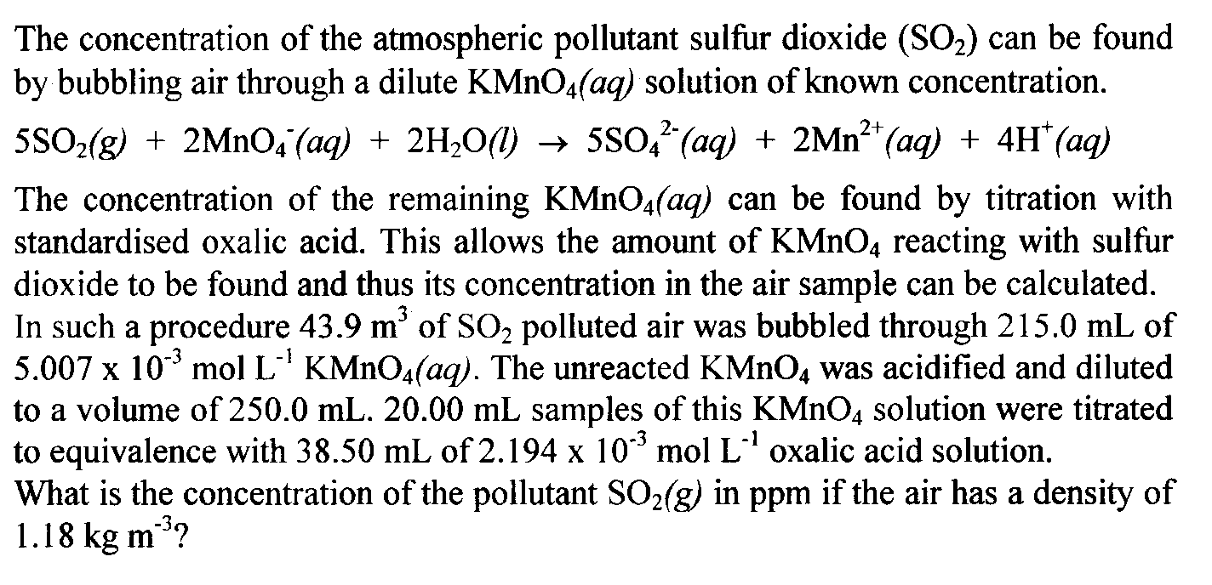
[12 marks]

_____________________________________________________________________

_____________________________________________________________________

_____________________________________________________________________

_____________________________________________________________________

_____________________________________________________________________

_____________________________________________________________________

_____________________________________________________________________

_____________________________________________________________________

_____________________________________________________________________

_____________________________________________________________________

_____________________________________________________________________

_____________________________________________________________________

_____________________________________________________________________

_____________________________________________________________________

_____________________________________________________________________

_____________________________________________________________________

_____________________________________________________________________

_____________________________________________________________________

_____________________________________________________________________

_____________________________________________________________________

_____________________________________________________________________

_____________________________________________________________________

_____________________________________________________________________

_____________________________________________________________________

_____________________________________________________________________

_____________________________________________________________________

_____________________________________________________________________

_____________________________________________________________________

_____________________________________________________________________

_____________________________________________________________________

_____________________________________________________________________

_____________________________________________________________________

_____________________________________________________________________

_____________________________________________________________________

_____________________________________________________________________

_____________________________________________________________________

_____________________________________________________________________

_____________________________________________________________________

_____________________________________________________________________

_____________________________________________________________________

_____________________________________________________________________

_____________________________________________________________________

_____________________________________________________________________

_____________________________________________________________________

Question 6

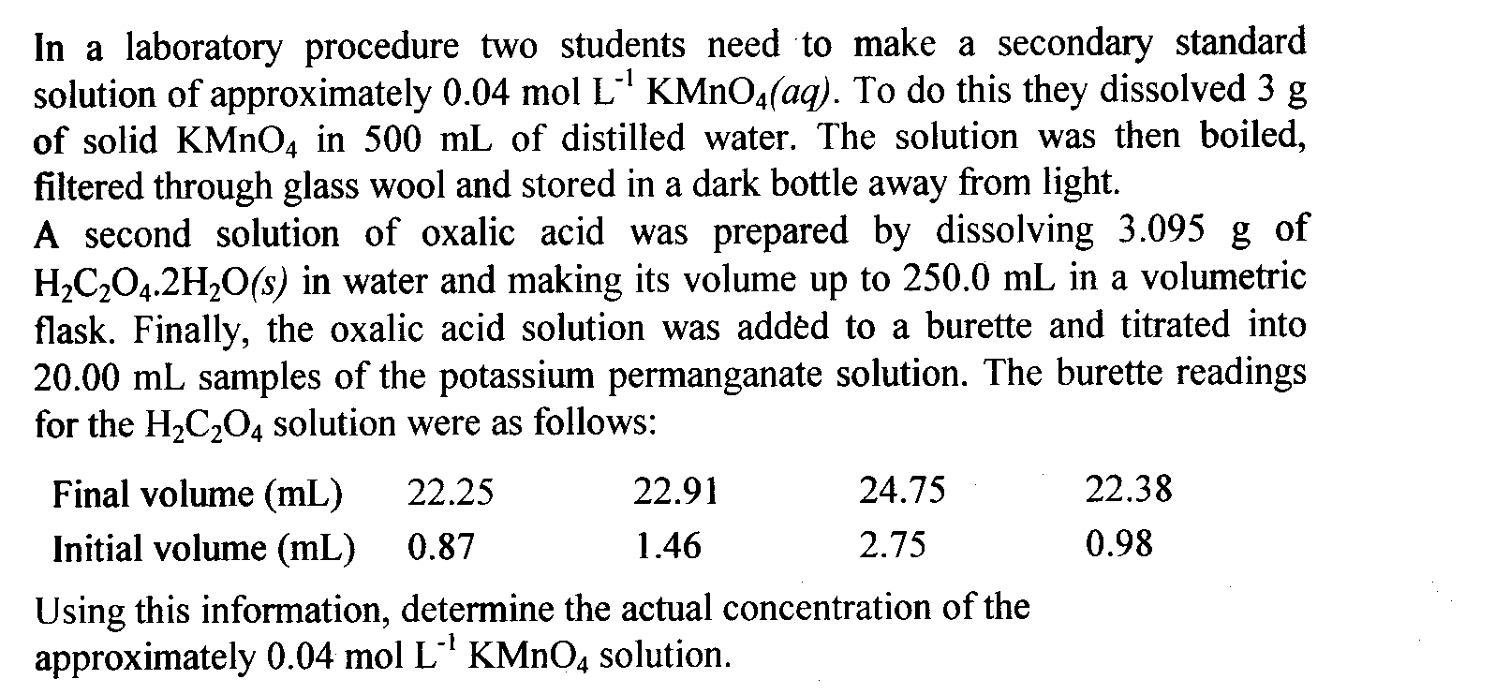
[7 marks]

_____________________________________________________________________

_____________________________________________________________________

_____________________________________________________________________

_____________________________________________________________________

_____________________________________________________________________

_____________________________________________________________________

_____________________________________________________________________

_____________________________________________________________________

_____________________________________________________________________

_____________________________________________________________________

_____________________________________________________________________

_____________________________________________________________________

_____________________________________________________________________

_____________________________________________________________________

_____________________________________________________________________

_____________________________________________________________________

_____________________________________________________________________

_____________________________________________________________________

_____________________________________________________________________

_____________________________________________________________________

_____________________________________________________________________

_____________________________________________________________________

_____________________________________________________________________

_____________________________________________________________________

_____________________________________________________________________

_____________________________________________________________________

_____________________________________________________________________

_____________________________________________________________________

_____________________________________________________________________

_____________________________________________________________________

_____________________________________________________________________

_____________________________________________________________________

_____________________________________________________________________

_____________________________________________________________________

_____________________________________________________________________

_____________________________________________________________________

_____________________________________________________________________

_____________________________________________________________________

_____________________________________________________________________

_____________________________________________________________________

_____________________________________________________________________

_____________________________________________________________________

_____________________________________________________________________

PART 4 (20 marks = 10% of paper)

Answer ONE of the following extended answer questions. Where applicable use equations, diagrams and illustrative examples of the chemistry you are describing.

Marks are awarded for the relevant chemical content of your answer, but also for coherence and clarity of expression. Your answer should be presented in about 1.5 - 2 pages. Begin your essay on the lined page following the end of the questions.
_____________________________________________________________________

1. You are to present a series of laboratory sessions on acid-base volumetric analysis. Discuss what you would present and why keeping in mind the importance of good laboratory technique, the correct use of various pieces of equipment and the need for primary and secondary standards.

OR

2. Compare and contrast the reactions involved in the chemical purification and extraction reactions for gold and iron. In what way are the differences in the properties of these two metals evident in the use of the metals in everyday life?

END OF QUESTIONS

_____________________________________________________________________

_____________________________________________________________________

_____________________________________________________________________

_____________________________________________________________________

_____________________________________________________________________

_____________________________________________________________________

_____________________________________________________________________

_____________________________________________________________________

_____________________________________________________________________

_____________________________________________________________________

_____________________________________________________________________

_____________________________________________________________________

_____________________________________________________________________

_____________________________________________________________________

_____________________________________________________________________

_____________________________________________________________________

_____________________________________________________________________

_____________________________________________________________________

_____________________________________________________________________

_____________________________________________________________________

_____________________________________________________________________

_____________________________________________________________________

_____________________________________________________________________

_____________________________________________________________________

_____________________________________________________________________

_____________________________________________________________________

_____________________________________________________________________

_____________________________________________________________________

_____________________________________________________________________

_____________________________________________________________________

_____________________________________________________________________

_____________________________________________________________________

_____________________________________________________________________

_____________________________________________________________________

_____________________________________________________________________

_____________________________________________________________________

_____________________________________________________________________

_____________________________________________________________________

_____________________________________________________________________

_____________________________________________________________________

_____________________________________________________________________

_____________________________________________________________________

_____________________________________________________________________

_____________________________________________________________________

_____________________________________________________________________

_____________________________________________________________________

_____________________________________________________________________

_____________________________________________________________________

_____________________________________________________________________

_____________________________________________________________________

_____________________________________________________________________

_____________________________________________________________________

_____________________________________________________________________

_____________________________________________________________________

_____________________________________________________________________

_____________________________________________________________________

_____________________________________________________________________

_____________________________________________________________________

_____________________________________________________________________

_____________________________________________________________________

_____________________________________________________________________

_____________________________________________________________________

_____________________________________________________________________

_____________________________________________________________________

_____________________________________________________________________

_____________________________________________________________________

_____________________________________________________________________

_____________________________________________________________________

_____________________________________________________________________

_____________________________________________________________________

_____________________________________________________________________

_____________________________________________________________________

_____________________________________________________________________

_____________________________________________________________________

_____________________________________________________________________

_____________________________________________________________________

_____________________________________________________________________

_____________________________________________________________________

_____________________________________________________________________

_____________________________________________________________________

_____________________________________________________________________

_____________________________________________________________________

_____________________________________________________________________

_____________________________________________________________________

_____________________________________________________________________

_____________________________________________________________________

_____________________________________________________________________

_____________________________________________________________________

_____________________________________________________________________

_____________________________________________________________________

_____________________________________________________________________

_____________________________________________________________________

_____________________________________________________________________

_____________________________________________________________________

_____________________________________________________________________

_____________________________________________________________________

_____________________________________________________________________

_____________________________________________________________________

_____________________________________________________________________

_____________________________________________________________________

_____________________________________________________________________

_____________________________________________________________________

_____________________________________________________________________

_____________________________________________________________________

_____________________________________________________________________

_____________________________________________________________________

_____________________________________________________________________

_____________________________________________________________________

_____________________________________________________________________

_____________________________________________________________________

_____________________________________________________________________

_____________________________________________________________________

_____________________________________________________________________

_____________________________________________________________________

_____________________________________________________________________

_____________________________________________________________________

_____________________________________________________________________

_____________________________________________________________________

_____________________________________________________________________

_____________________________________________________________________

_____________________________________________________________________

_____________________________________________________________________

_____________________________________________________________________

_____________________________________________________________________

_____________________________________________________________________

_____________________________________________________________________

_____________________________________________________________________

_____________________________________________________________________

_____________________________________________________________________

_____________________________________________________________________

_____________________________________________________________________

_____________________________________________________________________

_____________________________________________________________________

_____________________________________________________________________

_____________________________________________________________________

_____________________________________________________________________

_____________________________________________________________________

_____________________________________________________________________

_____________________________________________________________________

_____________________________________________________________________

_____________________________________________________________________

_____________________________________________________________________

_____________________________________________________________________

_____________________________________________________________________

_____________________________________________________________________

_____________________________________________________________________

_____________________________________________________________________

_____________________________________________________________________

_____________________________________________________________________

_____________________________________________________________________

_____________________________________________________________________

_____________________________________________________________________

_____________________________________________________________________

_____________________________________________________________________

_____________________________________________________________________

_____________________________________________________________________

_____________________________________________________________________

END OF PAPER

